
Bahria University, Lahore Campus
Department of Computer Science
Lab Journal 02
(Fall 2025)

Course: | Introduction to Data Science - Lab | Date: 15/10/2025
Course Code: | CSL-487 | Max Marks: 20
Faculty’s Name: | Mr. Muhammad Umar Tariq

Name: Khawaja Fahad Zia Enroll No: 03-134221-057 Class: BSCS 6A_____________

Objective(s):
Upon completion of this lab session, learners will be able to:
- Understand key concepts of dataset structure, size, and types of data collection methods.
- Apply essential data preprocessing techniques such as handling missing values, encoding, and normalization.
- Implement machine learning models including Random Forest and SVM for classification tasks.
- Evaluate model performance using accuracy, confusion matrix, and classification reports.

Lab Tasks:

Task 1: Dataset Understanding, Data Collection, and Implementation

Instructions: Take Help from the Data collection file and answer the following questions

- If a dataset has 1000 rows and 25 columns, what do the terms size and dimensionality represent in this context?

Answer:

Size: (1000,25)
Dimensionality: 25
- Suppose a dataset contains product reviews with both text comments and numerical ratings. Would this dataset be structured, unstructured, or semi-structured — and why?
Answer:
It is unstructured data because it is not in the form of rows and columns nor it has any predefined structure like json.

- If a researcher collects temperature readings automatically from smart home devices, which type of data collection is being used — primary or secondary — and why?
Answer:
Primary data collection is being used as we are collecting dataset ourselves and not from another source.
- A company downloads customer reviews from Amazon using a Python script. Which data collection method does this represent, and how is it different from using surveys?
Answer:
It is secondary data collection using web scraping as we are using tools to collect data from the internet. Surveys involve people willingly answering your questions whereas in scraping you scour the web for data and collect it.
- If a student uses data from the World Bank website to analyze global poverty trends, which type of data collection is this, and why is it not considered primary data?
Answer:
It is secondary data collection. It would be a public dataset or scraping depending on the type of technique used on the website.

Task 2: Data Preprocessing
Instructions: Take Help from the Data preprocessing file and answer the following questions
- If a dataset has missing income values only for people with high salaries, which type of missing data is this — MCAR, MAR, or MNAR — and why?

Answer:
This is MNAR as the missing value depends on itself.
- You find that “New York,” “nyc,” and “new york” appear as different entries in your dataset.
  - What type of data problem is this?

Answer:
In this inconsistent data problem same value is stored differently in different records.
  - Which preprocessing technique should be applied to fix it?
Answer:

We will apply techniques for inconsistent data.

- A categorical column “Size” has values Small, Medium, Large.
  - Which encoding method (Label, One-Hot, or Ordinal) is most appropriate and why?
Answer:
Ordinal Encoding is the most appropriate as the data has clear hierarchy.
- After merging two datasets, you notice duplicate entries where the same customer appears twice but with missing information in different fields.
  - What is the best approach to handle these duplicates, and why shouldn’t you just delete one row?
Answer:
We can merge the duplicate rows in order to get the complete information and then remove the duplicates. If we delete without considering anything then we will lose the full picture.
- Your dataset contains a “Salary” column (values in thousands) and an “Age” column (values in years).
  - Why might scaling or normalization be necessary before training a ML model.
Answer:
Scaling is necessary as the model might prioritize Salary more as it has larger values and believe that age has less impact because of its low values.
Task 3: Practical Implementation – Data Preprocessing and Model Training

Objective:
To apply the complete process of data preprocessing, visualization, model training, and evaluation using Python and machine learning libraries.

Instructions:
Your task is to create a Jupyter Notebook and implement a Machine Learning Cycle (training phase, testing phase, application phase) for the Heart Disease Prediction dataset. The complete dataset is given.

Follow the steps below and provide code implementation with outputs.

Steps:
- Import Required Libraries
Import all the necessary Python libraries such as:
  - numpy, pandas, matplotlib, seaborn
  - pickle (for model saving)
  - scikit-learn (for preprocessing, model training, and evaluation)
- Load and Explore the Dataset
  - Load the dataset using pandas.read_csv()
  - Display the first few records using .head()
  - Check the shape, datatypes, and basic statistics of the dataset

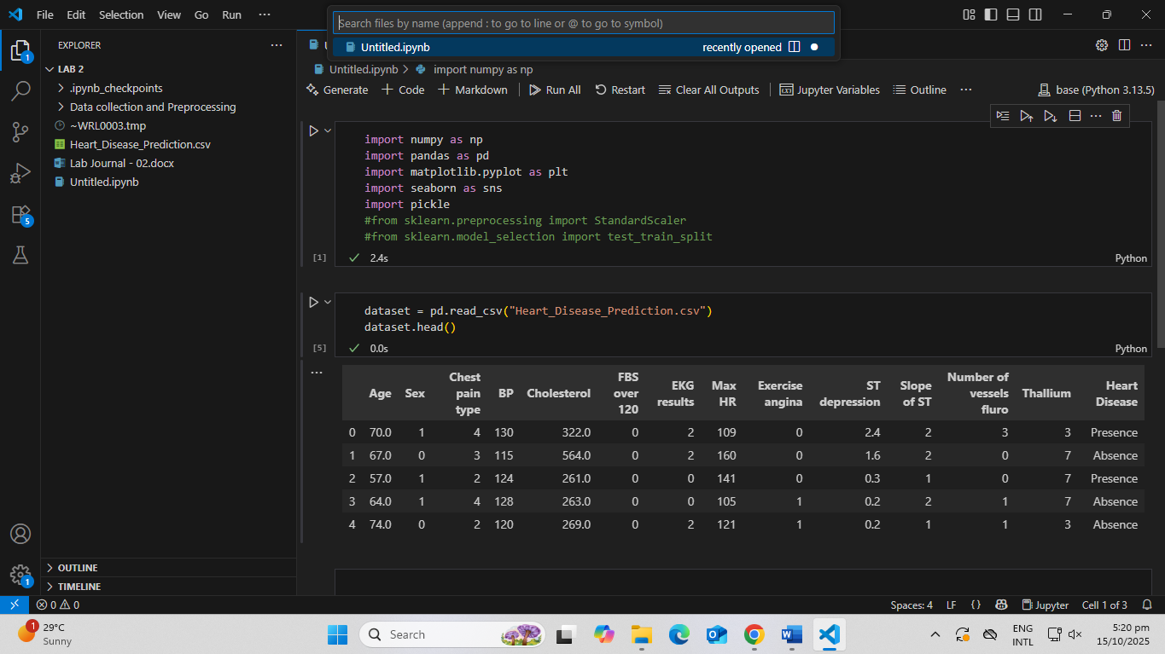
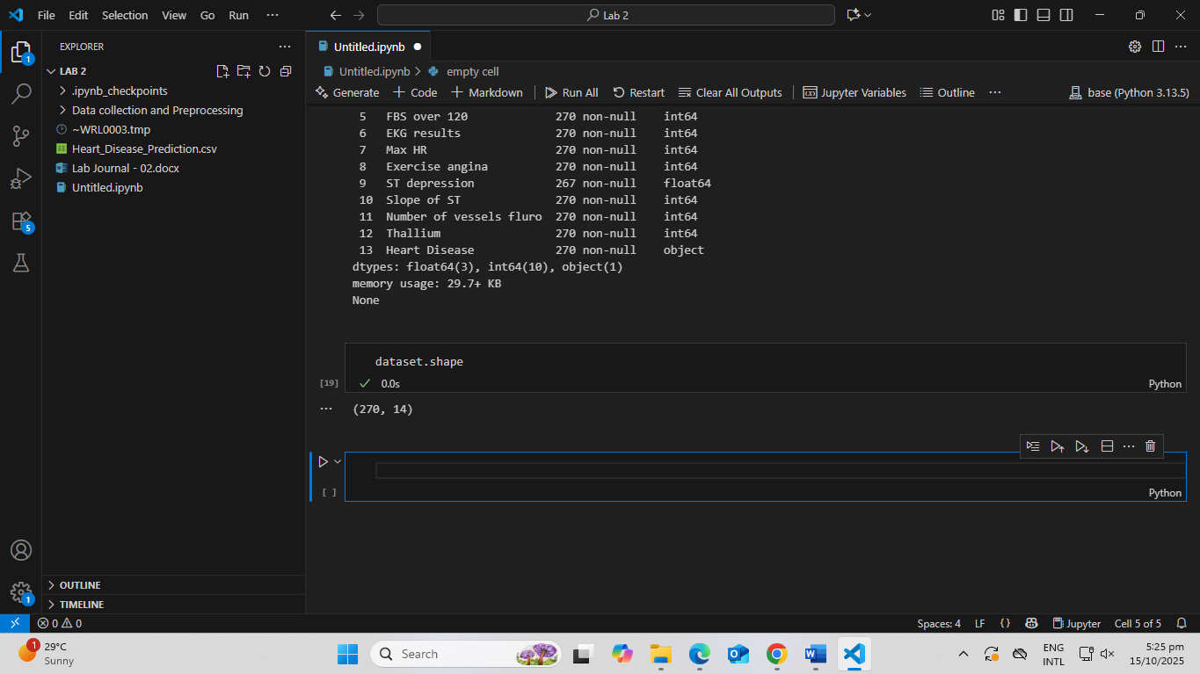
- Feature Selection
  - Identify and select the most relevant attributes for the analysis
  - Remove or drop unnecessary columns (if any)

The Heart Disease column depends on all the features so we will not drop any columns.

- Display Input and Output Columns
  - Clearly define which columns represent input features (X) and which represent the output label (y)

Heart Disease: Output Label (y)
Age: Input Label (x)
Sex: Input Label (x)
Chest pain type: Input Label (x)
BP: Input Label (x)
Cholesterol: Input Label (x)
FBS over 120: Input Label (x)
EKG results: Input Label (x)
Max HR: Input Label (x)
Exercise angina: Input Label (x)
ST depression: Input Label (x)
Slope of ST: Input Label (x)
Number of vessels fluro: Input Label (x)
Thallium: Input Label (x)

- Data Preprocessing
Apply appropriate preprocessing techniques such as:
  - Handling missing data

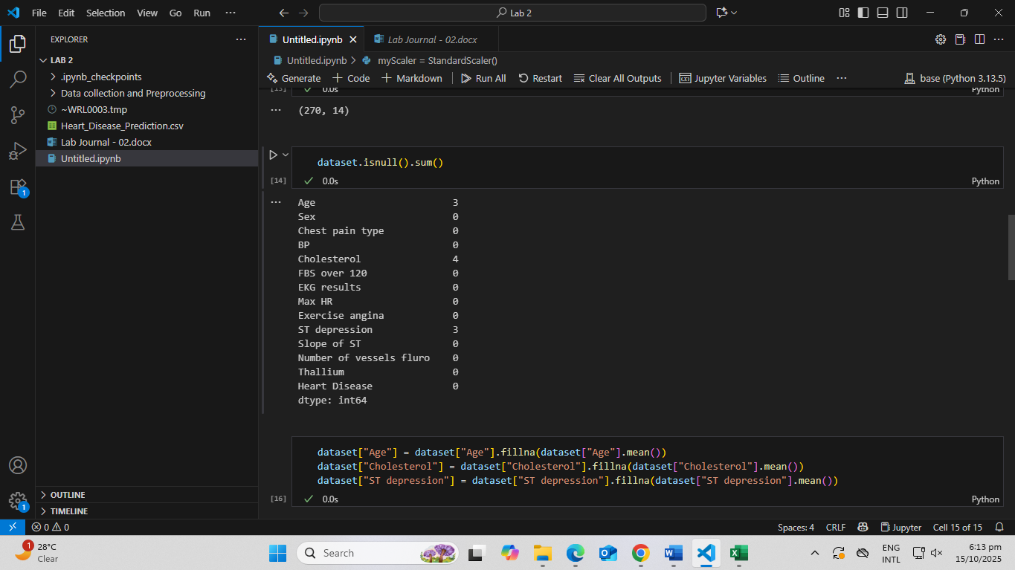
  - Encoding categorical variables

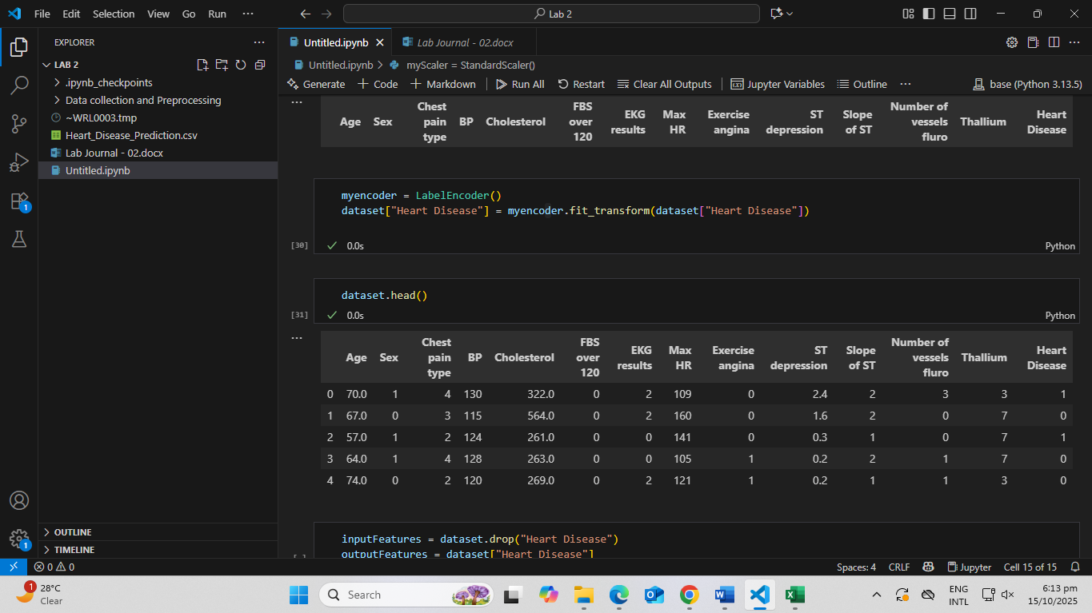

  - Removing duplicates or inconsistencies

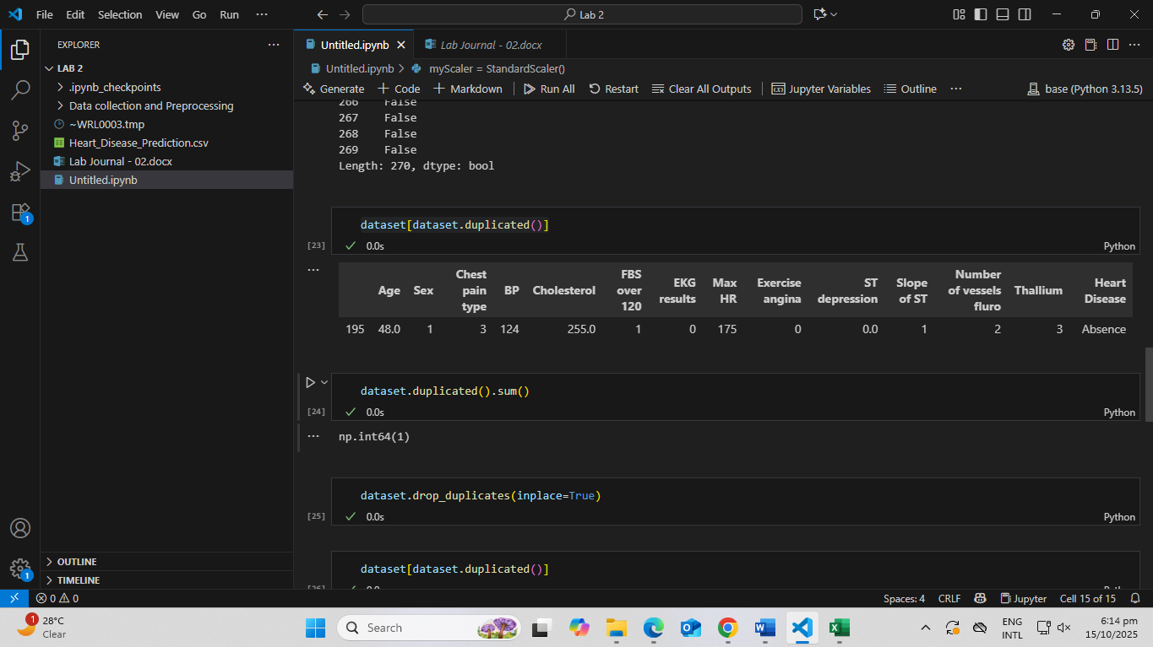

  - Scaling or normalization (if needed)
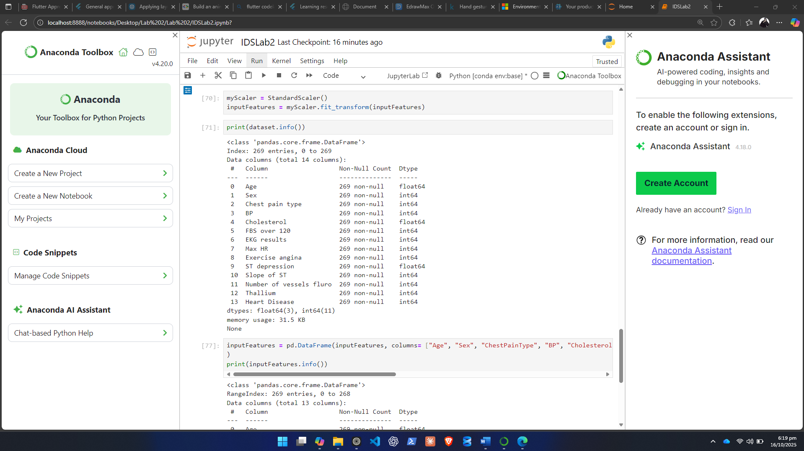
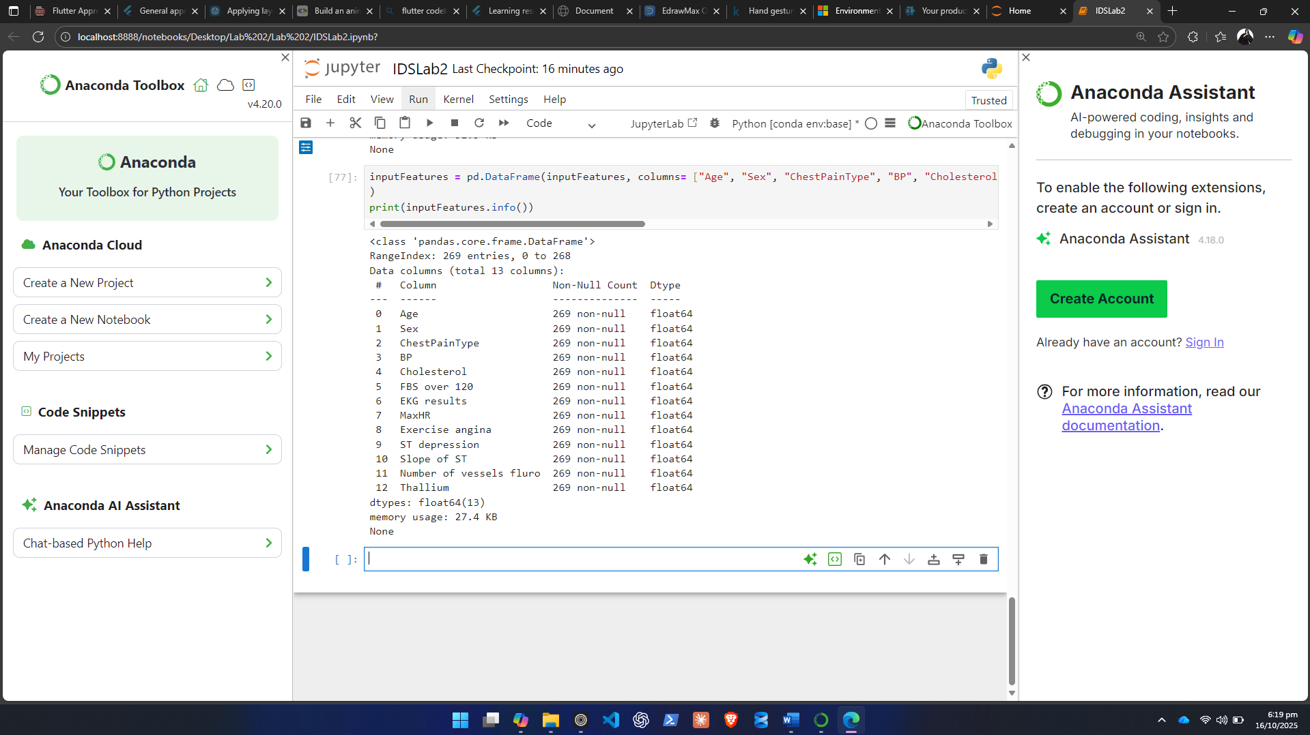

- Data Visualization and Insights
  - Use visual tools to explore and understand data patterns
  - Recommended visualizations:
    - Bar charts
    - Count plots
    - Boxplots
    - Correlation heatmap

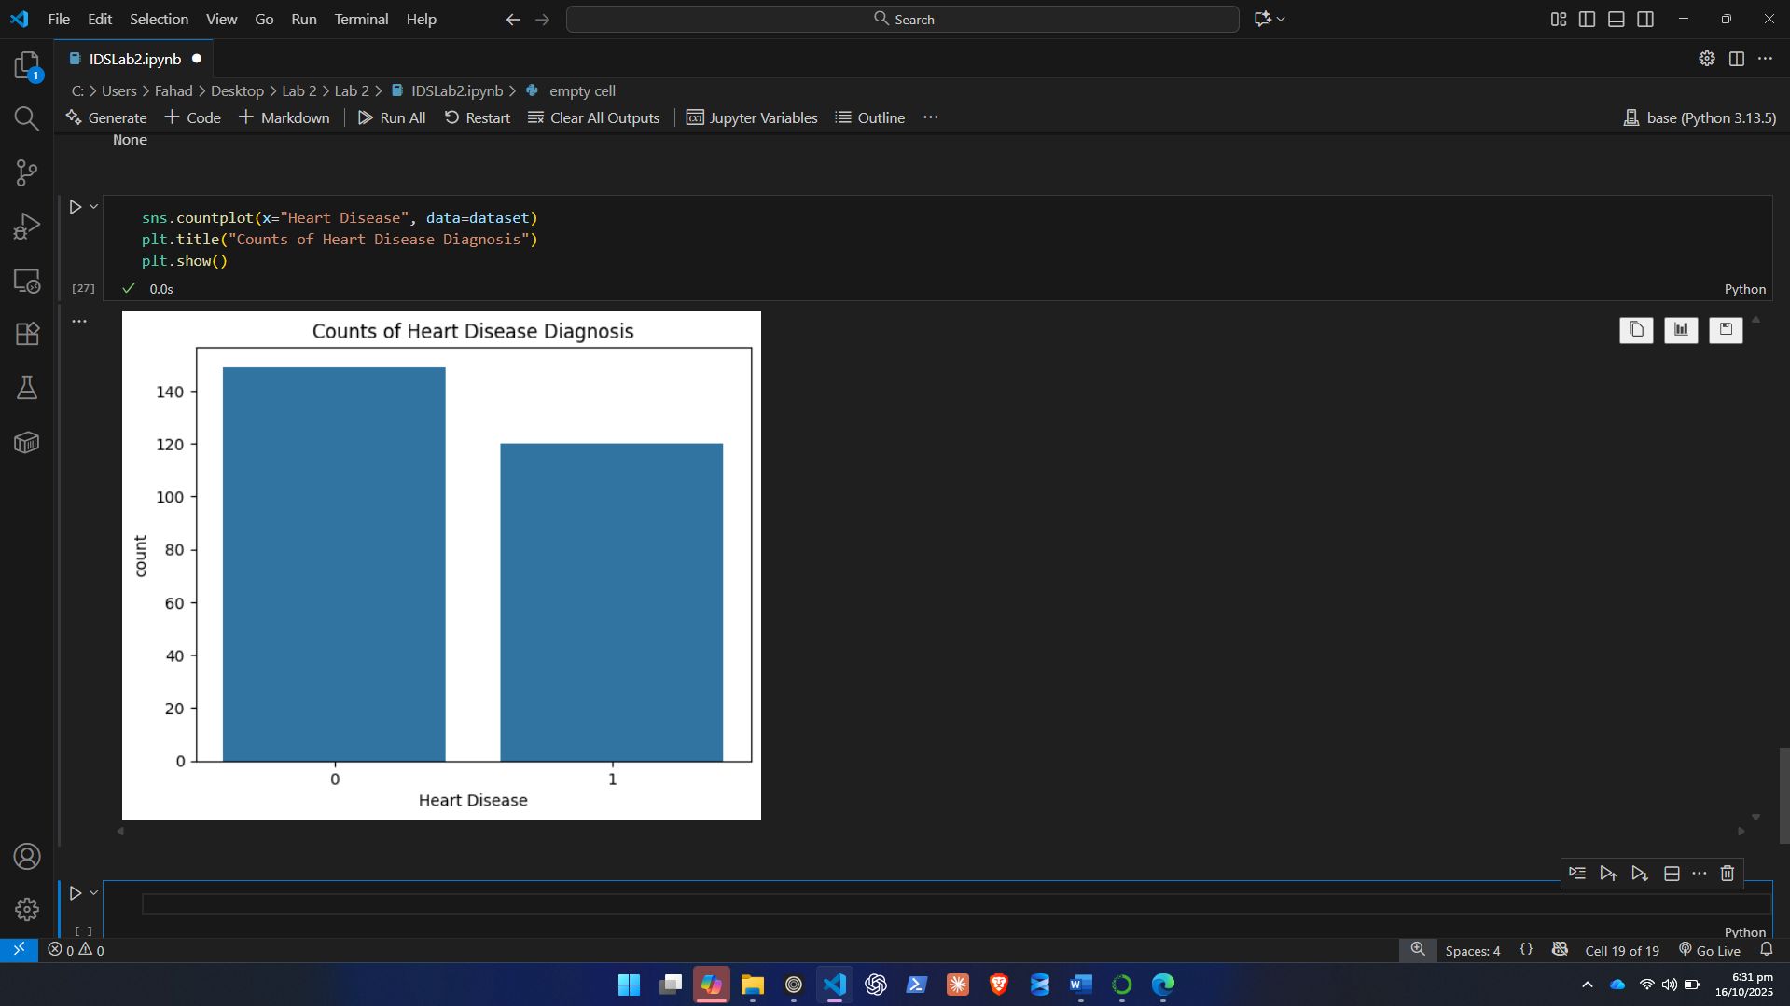
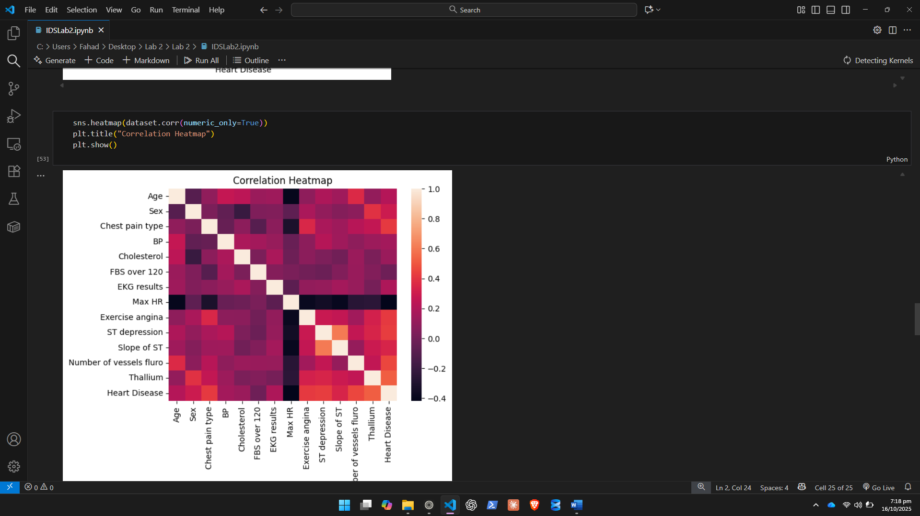
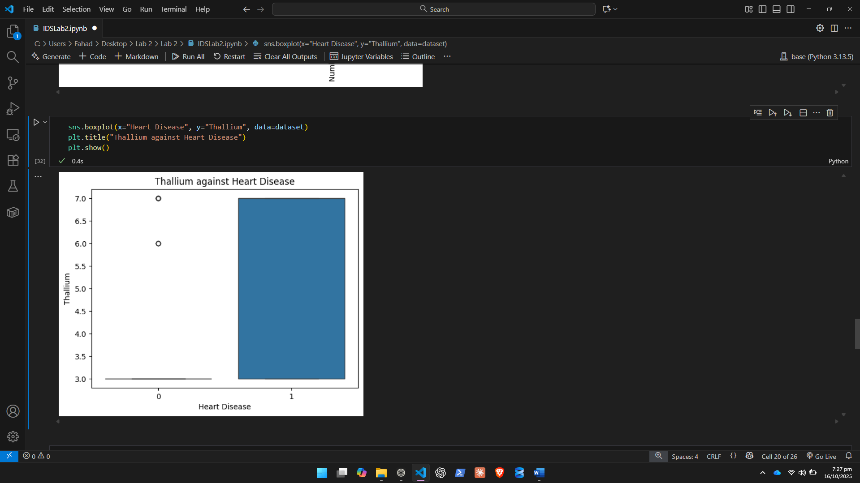

- Split Dataset into Features and Labels
  - Separate the dataset into input features (X) and output labels (y)

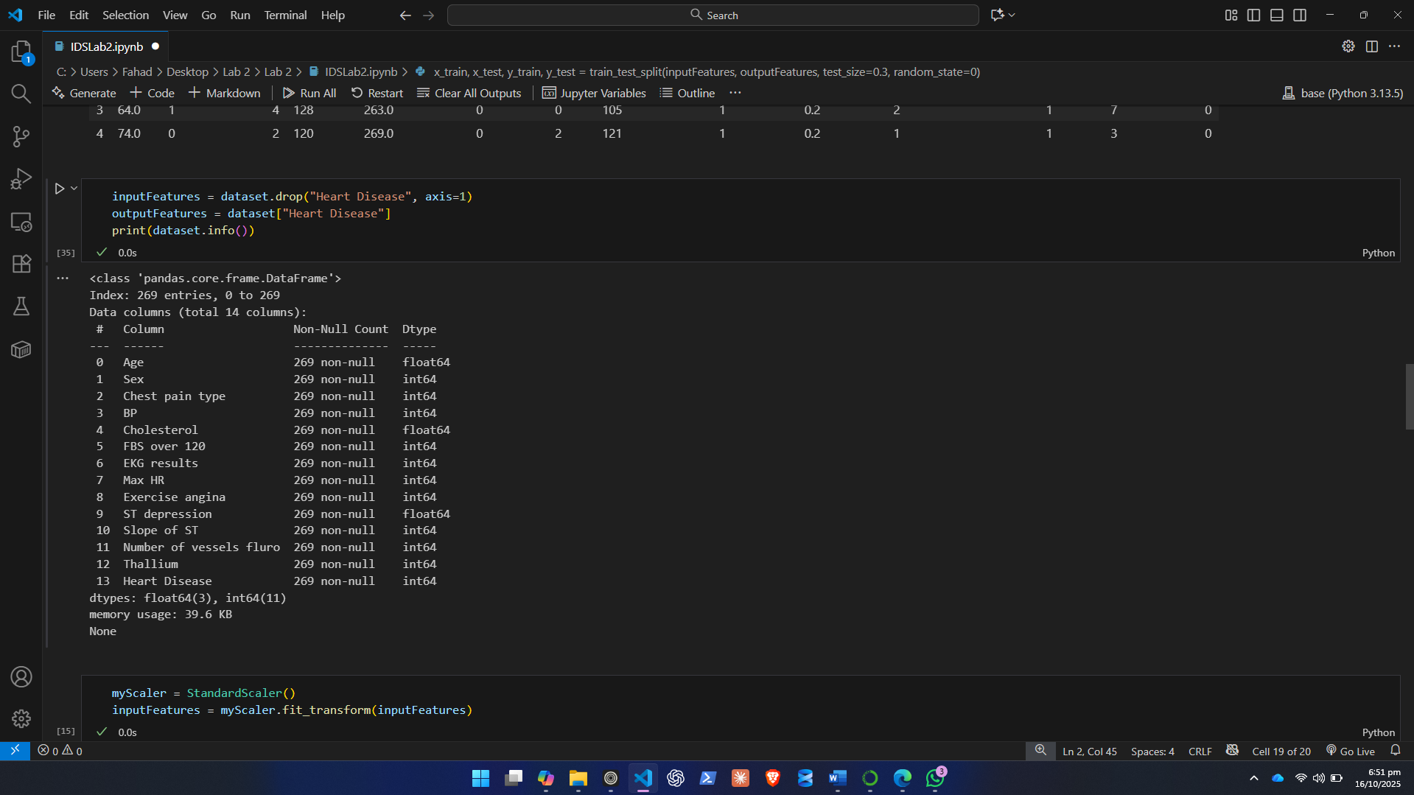
- Train-Test Split
  - Split the dataset into training and testing sets in a 70:30 ratio using train_test_split()

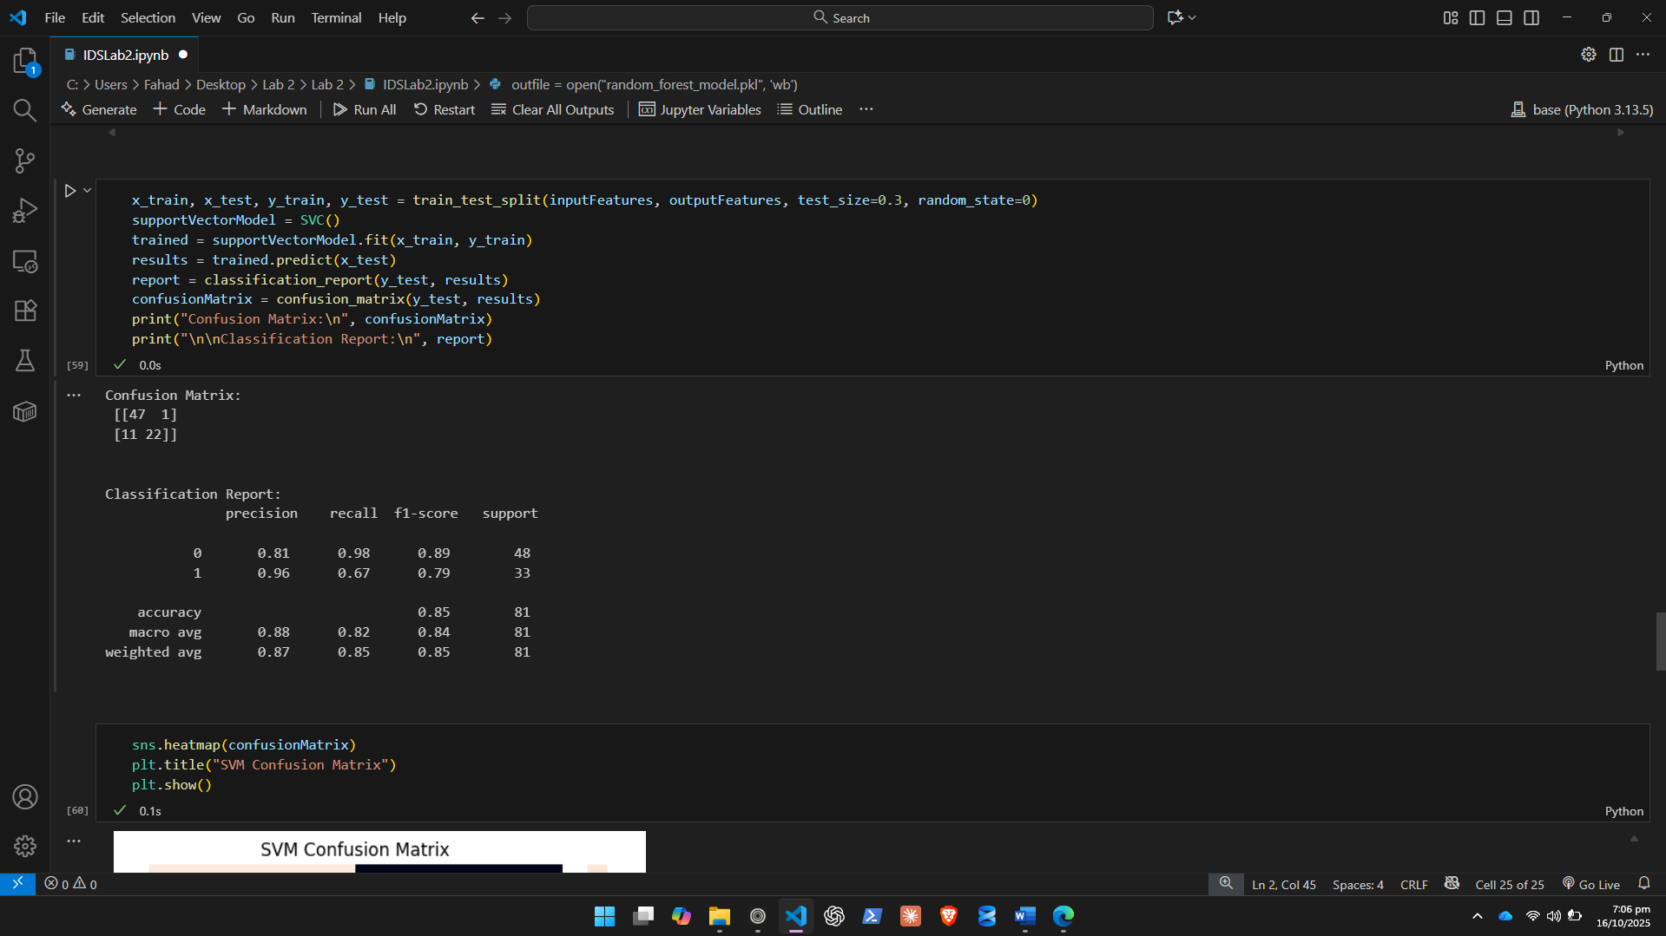
- Model Training
Train the dataset using two machine learning algorithms:
  - Random Forest Classifier

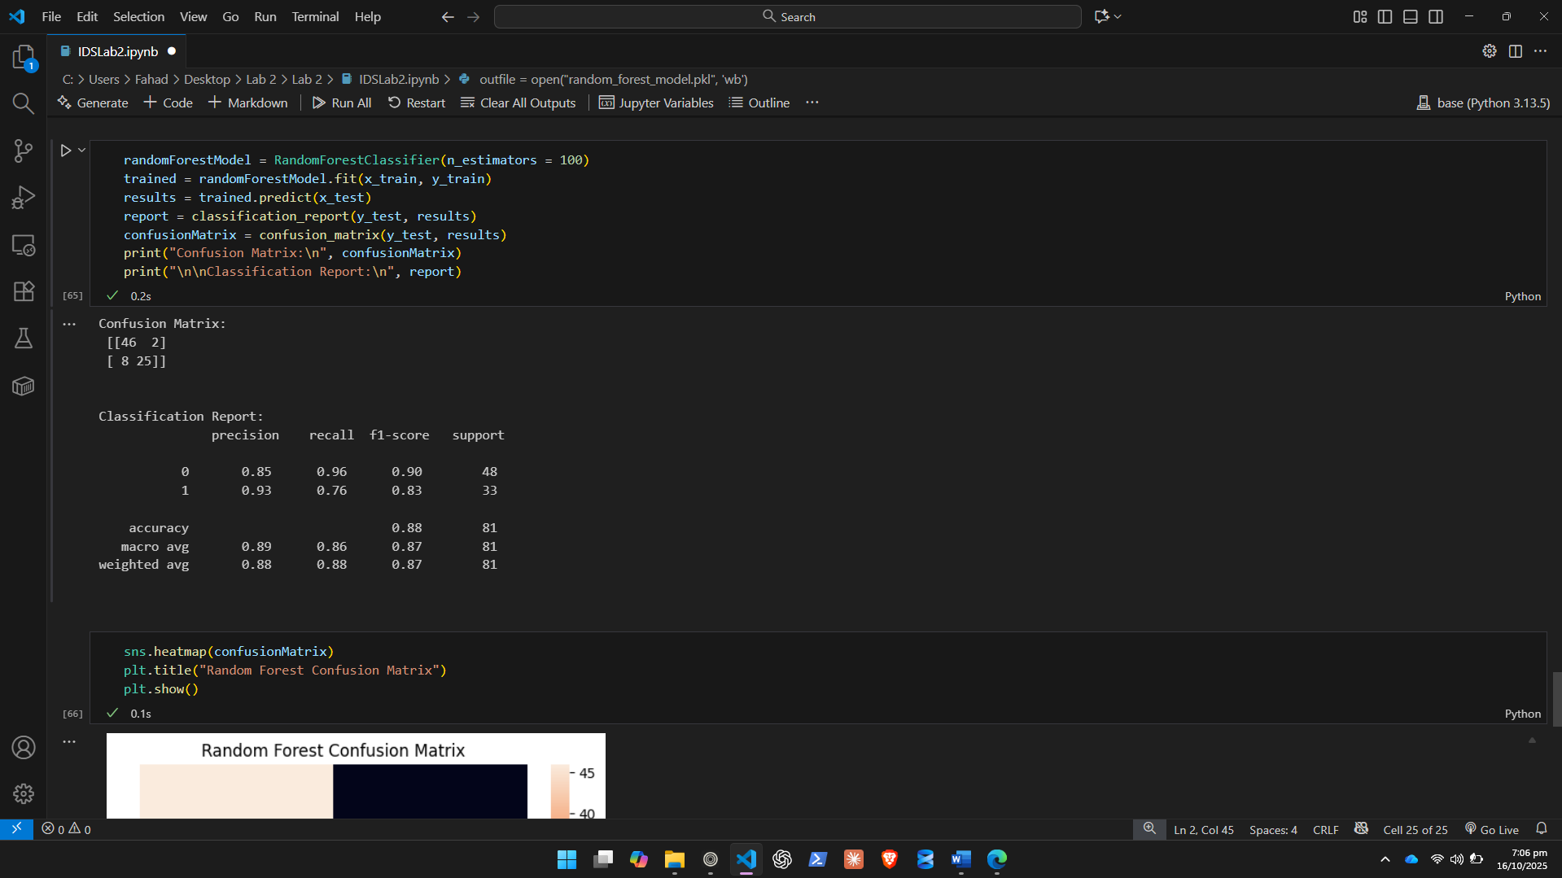

  - Support Vector Machine (SVM)
- Model Evaluation
  - Evaluate both models using accuracy, precision, recall, and F1-score
  - Use the classification_report() from scikit-learn

- Confusion Matrix
  - Generate and plot the confusion matrix for each model
  - Visualize it using seaborn.heatmap()

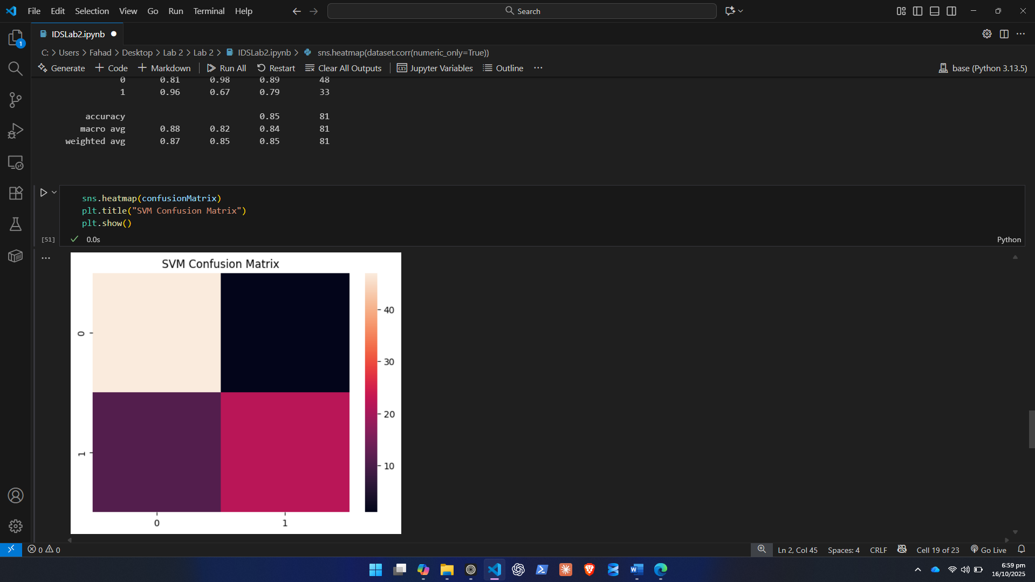
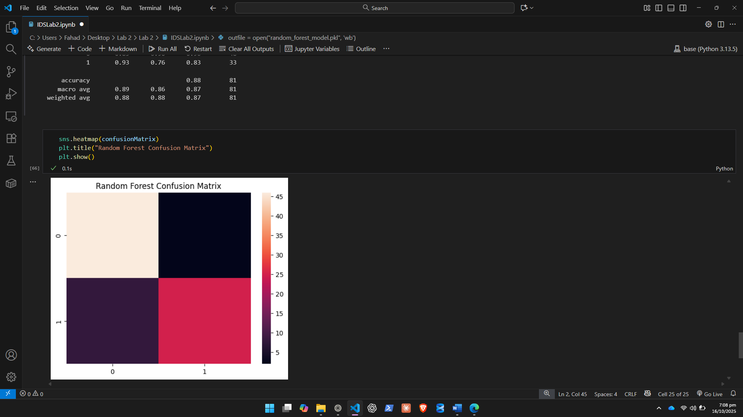
- Model Saving (Optional)
  - Save the trained model using pickle.dump() for future use

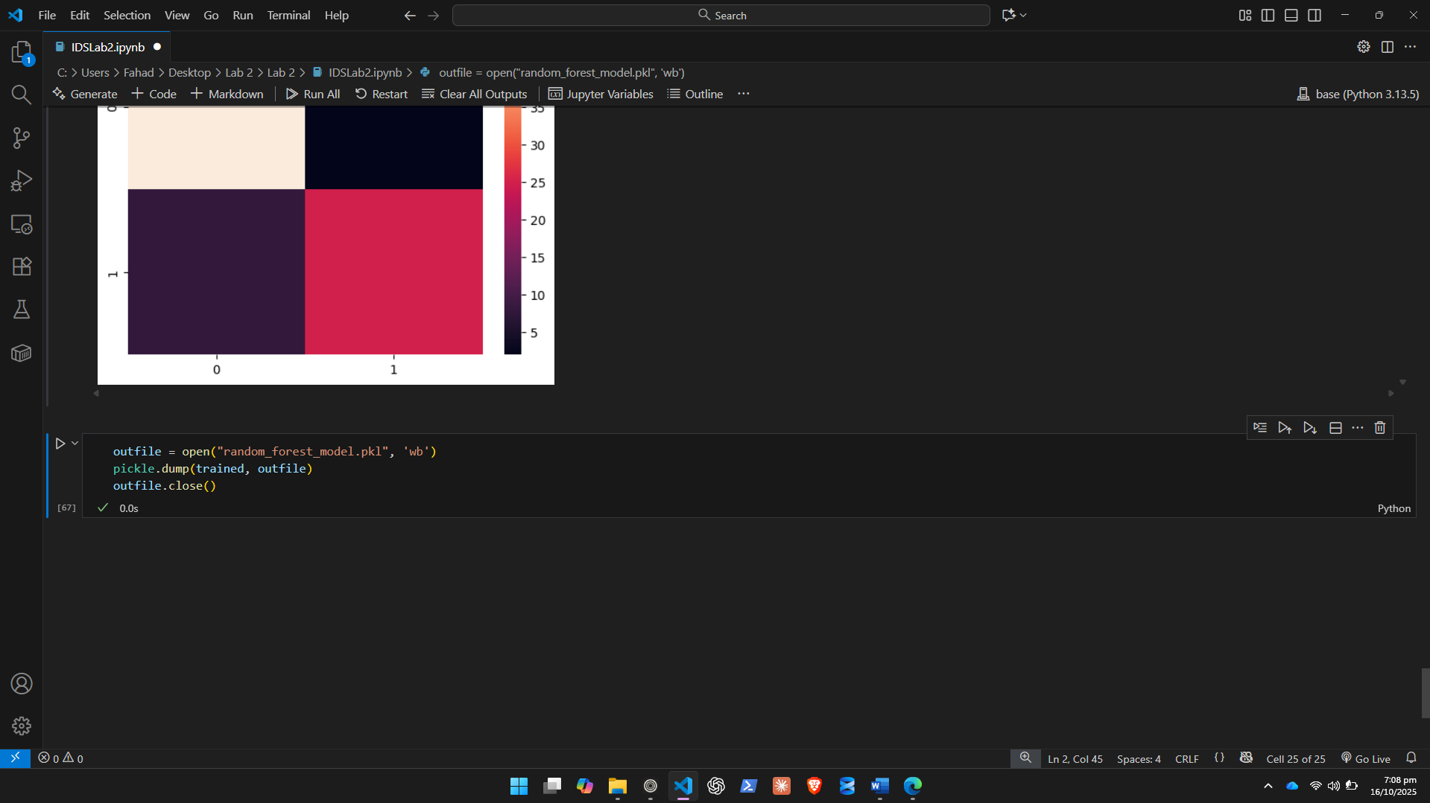
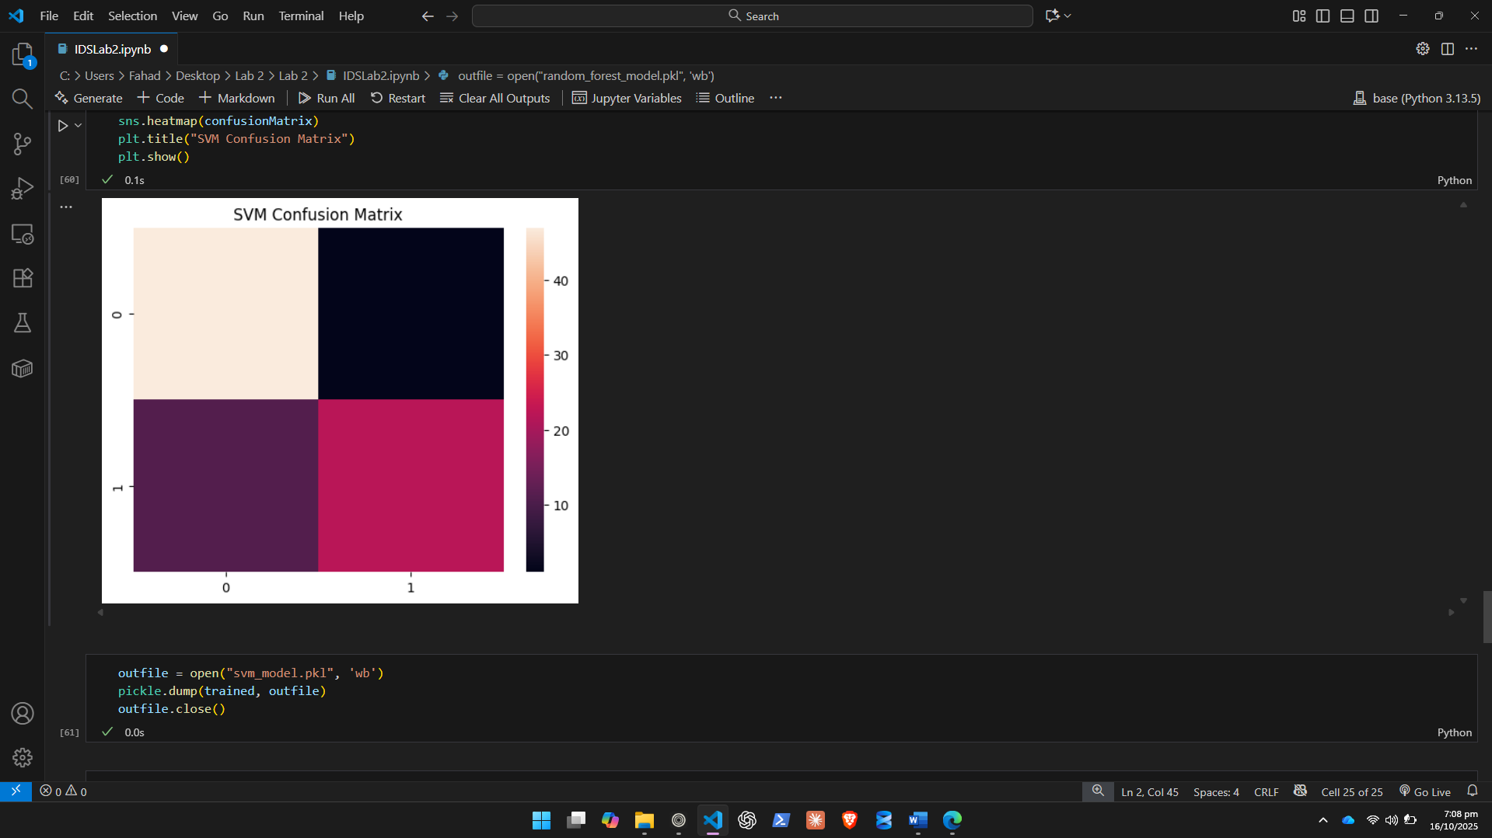
Deliverables:
- Python code implementation (.ipynb or .py file)
- Output screenshots of each major step
- A short summary of which model performed better and why

Summary:

Both models performed almost entirely the same. The differences are negligible. Both have 0.87 and 0.88 weighted accuracy while SVM has slightly less score. Random Forest usually leverages higher computation and makes different decision trees which may or may nt use the same data multiple times in multiple configurations to achieve better results so it generally works better but here the difference is pretty small.

Lab Grading Sheet:
Task | Max Marks | Obtained Marks | Comments(if any)
1. | 05
2. | 05
3. | 10
Total | 20 |  | Signature

Note : Attempt all tasks and get them checked by your Lab Instructor.

